Algorithm for file updates in Python

Project Description

In order to control access, at this organisation, I have to use an allow list of IP addresses. There is a file called “allow_list.txt” which consists of the allowed IP addresses and a separate list that contains the addresses that should no longer be granted access, hence removed from the allowed list. I created an algorithm that automates going through the allow list file and removing any IP addresses that should lose access and so updating the list.

Open the file that contains the allow list
First, the file name is assigned to the import_file variable as a string, then I used with open() to open it as a file in “r” - reading mode. Using “with” closes a file after you are done with it, and opening with “r” to read it serves the function to show me the IP addresses that are allowed access. The open() function has 2 parameters - first one is the file that will be opened and the second one dictates how the file is opened - that is, as reading, writing and appending. The keyword “as” saves the file as a variable named file, as the output of open() so it can be easily referenced in the next lines, as long as it’s still within the with statement.

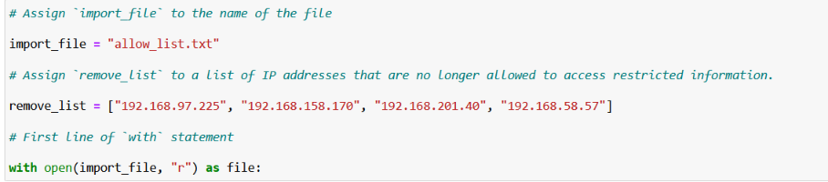

Convert the string into a list
I have used the function .split() in order to make it easier to remove the ip addresses from the allow list. The function works by separating a string into a list, by stopping at each whitespace. I have stored the output into a variable called ip_addresses.
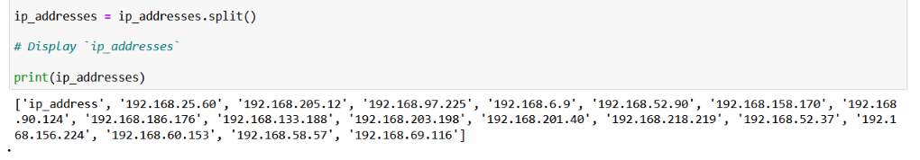

Read the file contents
I have used the argument “r”, which allows me to call the function .read(), converting the file into a string in a readable format for me . After that, I have stored the output in a ip_addresses variable.

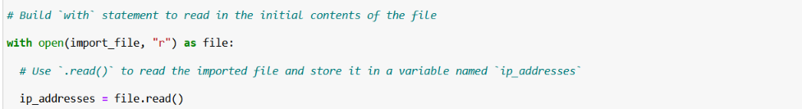

Iterate through the remove list
I have used a for loop to iterate through each ip address in ip_addresses.

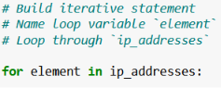
The code instructs to go through each element in the variable ip_addresses in a loop.

Remove IP addresses that are on the remove list
It starts with a for loop going through each element in ip_addresses, it adds the conditional if an element is in the remove list it gives the instructions by calling the function .remove() with a parameter element to remove it from the list.
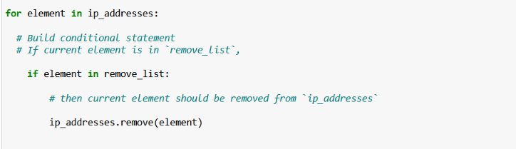

Update the file with the revised list of IP addresses
The first thing I had to do to update the allow list after removing certain ip addresses from it was to convert it back into a string using .join (). The .join() function can combine all the elements in an iterable into a single string. I have used “ “ .join() to combine all the IP addresses in the list back into a string, with a space between each IP address. This allows the string to be written back to the text file.

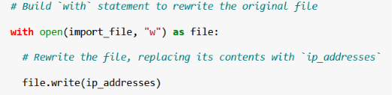
I have used a with open() statement once again to make sure the file closes automatically after I'm finished with it, to ensure the changes are saved correctly. The first parameter is the file I want to open and the second one is “w” which opens the file in a write mode. The file is assigned to the variable file, and file.write(ip_addresses) rewrites the contents of the file with an updated list of allowed IP addresses.

Summary
In this project, I have created an algorithm that removes IP addresses that are listed in a remove_list variable, from an allow_list.txt file containing the approved IP addresses. This algorithm involved opening the “allow_list.txt” file, converting its content into a string. The next step was to read the string and convert it into a list which I stored in the variable ip_addresses. After this, I made a for loop that iterates through each element in remove_list and checks whether it’s also in the ip_addresses list. I have added a conditional, if the element is in both lists, .remove() is performed to remove the IP address. After this I use .join() to convert the ip_addresses list back into a string so I can rewrite the contents of the “allow_list.txt” file with the updated allowed IP addresses.

